**Stage 2 - Halls of Montezuma**

**RULES:** USPSA Competition Rules, Latest Edition **COURSE DESIGNER:** Ike Starnes

|  |  |
| --- | --- |
| **START POSITION: See written stage briefing.** | |
| **STAGE PROCEDURE**  See written stage briefing. | **SCORING**  **SCORING:** Comstock 26 rounds.  **TARGETS:** There are 13 cardboard targets.  **SCORED HITS:** 2 Best hits per carboard will be scored.  **START-STOP:**  Audible - Last shot  **PENALTIES:** Per USPSA Competition Rules |

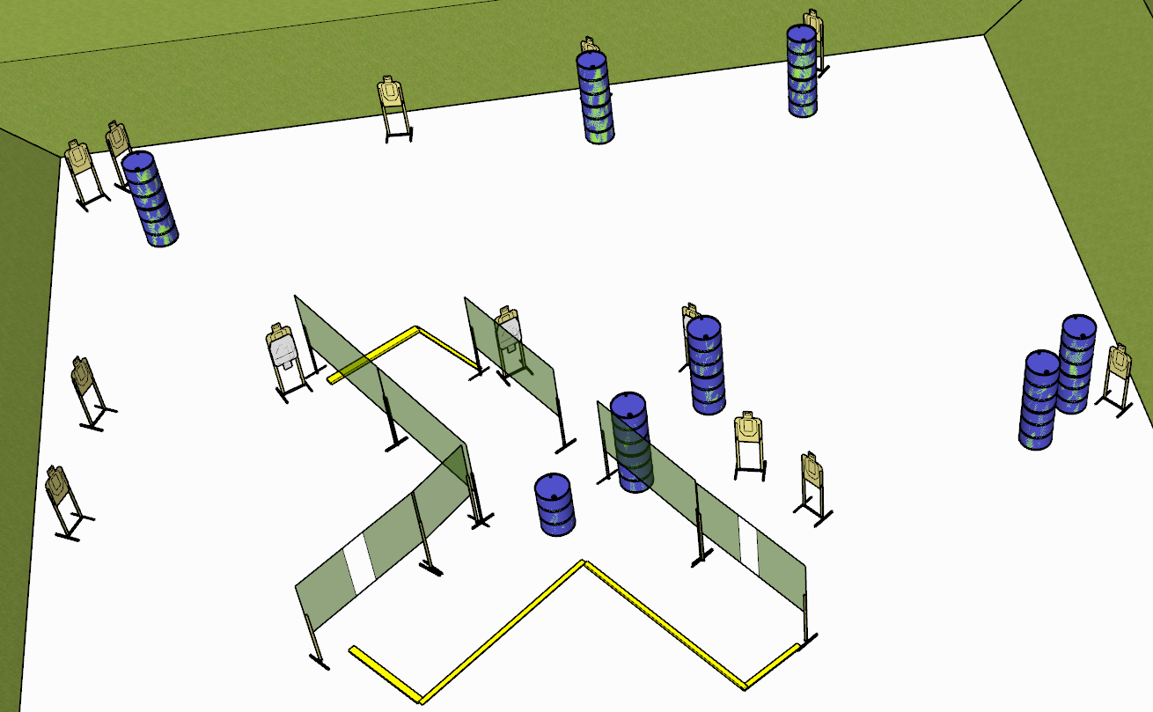

**Written Stage Briefing:**

**Stage 2 - Halls of Montezuma–** is a 26-round, 130 point, Comstock Long Course. There are 13 cardboard targets. The best 2 hits per cardboard target will be scored.

**Start position** Loaded firearm placed un-propped on barrel with muzzle pointed generally downrange, with hands over respective shoulders.

On the audible start signal, engage targets from within the shooting area.

**Setup Notes:**

For the no-shoot target in the center of the stage, give the shooters A LOT of A ZONE.

Rule 2.1.3 states steel targets must be at least 26 feet away if only fault lines are used.

Ensure that the “close” targets are stapled high enough on the target sticks such that rounds do not impact the deck of the bay.

Be sure to hydrate yourself.